FINISHED PRODUCT SPECIFICATION
Product Code & Description  LCB-1S  6 X 100 X 10g Coffee Bags  Blend No. 1 - Signature |  |  | 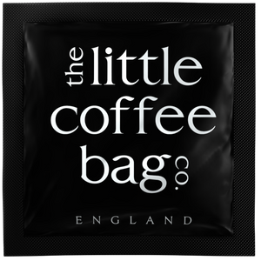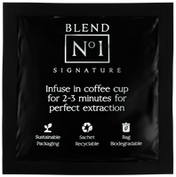
INGREDIENTS in descending order (allergens in bold)
Ground coffee (10g per coffee bag)

Further allergy advise (may contain/ cross contamination risk):

PRODUCT INFORMATION
Product suitability |  |  | Nutritional Information per 100g
Suitable for vegetarian diet |  | Yes | Energy- KJ |  | 0
Suitable for vegan diet |  | Yes | Kcal |  | 0
Suitable for Halal diet |  | Yes | Fat |  | 0g
Suitable for Kosher diet |  | Yes | of which saturated |  | 0g
Suitable for Coeliac |  | Yes | mono-unsaturated |  | 0g
Suitable for nut allergy sufferers |  | Yes | polyunsaturated |  | 0g
SHELF LIFE |  |  | Carbohydrate |  | 0g
1 year + |  |  | of which- sugars |  | 0g
Recommended Storage |  |  | Fibre |  | 0g
Ambient Storage.  Store in a cool dry place, away from direct sunlight |  |  | Protein |  | 0g
 |  |  | Salt (Na x 2.5) |  | 0g
PACKAGING INFORMATION
PACK SIZE (in cm) | 59 x 53 x 31 |  | TARGET FILL WEIGHT | 10g per coffee bag
PACKS PER CASE | 1 |  | CASES PER LAYER | 4
LAYERS PER PALLET | 4 |  | CASES ON PALLET | 16
PRODUCT PACKAGING- PRIMARY | PolyPropylene |  | PRODUCT PACKAGING- SECONDARY | Cardboard
BARCODE | 0634654722577 (INNER) |  | TRACEABILITY CODE | On Case Label
ISSUE DETAILS
NAME |  |  | Jesse Bate
POSITION |  |  | Sales & Marketing Exec
DATE OF ISSUE |  |  | 13/10/2023
ISSUE NUMBER
SIGNATURE |  |  | 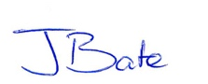
PACKED IN THE UK BY  (TRADED BY) |  |  | Packed by Masteroast Coffee Company for The Little Coffee Bag Co
To the best of our knowledge, we certify that the product (including any packaging, containers or labels), comply with current UK and EU Regulations.

