Product Description: | Dispenser Label Safe 2" 7 Slot
Material Grade: | Polypropylene
Material Colour: | N/A
Product Size: | 51mm
Material Thickness: | N/A
Product Code: | IT117505
Other: | N/A
Legislation: | All food contact packaging products supplied to RPS conform with EU Regulation 1935/2004 of the European Parliament on the Marketing of Materials and Articles Intended to Come into Contact with Food.  All direct food contact products do not contain PFA’s & PFC’s (Per-fluoro-chemicals)
Print Details: (No of Sides No of Colours): | N/A
Pantone Colour Reference (non-coated): | N/A
Outer / Transit Packaging (Material): | Loose

Packaging Details:  (products per case etc) | 1 unit equals 1 lid & 1 dispenser

Internal Barcode (if applicable): | 5060436132916
External Barcode:

Outer Packaging Type:
Outer Case: ☐ | Shrink Wrap: ☐ | Ream: ☐ | Other: ☐
Details:

Notes:
Holds 2” x 2” labels ( 500 labels per roll )

Pallet Type: | UK specification 4-way slatted 1200 x 1000mm
Boxes Per Pallet:
Products Per Box:
Max Pallet Hight: | 1.4m
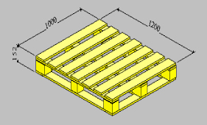

Label Detail:
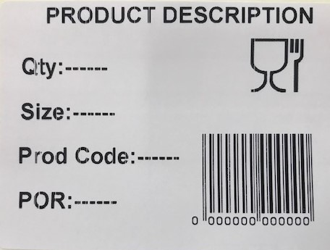
Label must include Full description / POR number / and barcode must be EAN Standard

Attached Artwork:


