16.10.2023

Dear Customer
I can confirm that all S.steel products and raw materials sourced are from ethical factories which includes Sedex approved suppliers and therefore confirm from Mill Reports that Beaumont and its suppliers do not source from Russia.

Yours sincerely
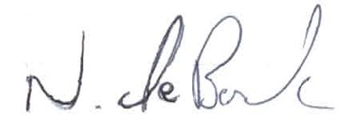

Nick de Borde

